Assignment 3
Compute and plot (show the image and its histogram) the histogram of flower.pgm, swan.pgm and tools.pgm. Comment on what information can be discerned about the images from an examination of the histogram.

Code:-
>> I = imread('C:\IMAGES\FLOWER.PGM');
>> figure,imshow(I);
>> figure,imhist(I);
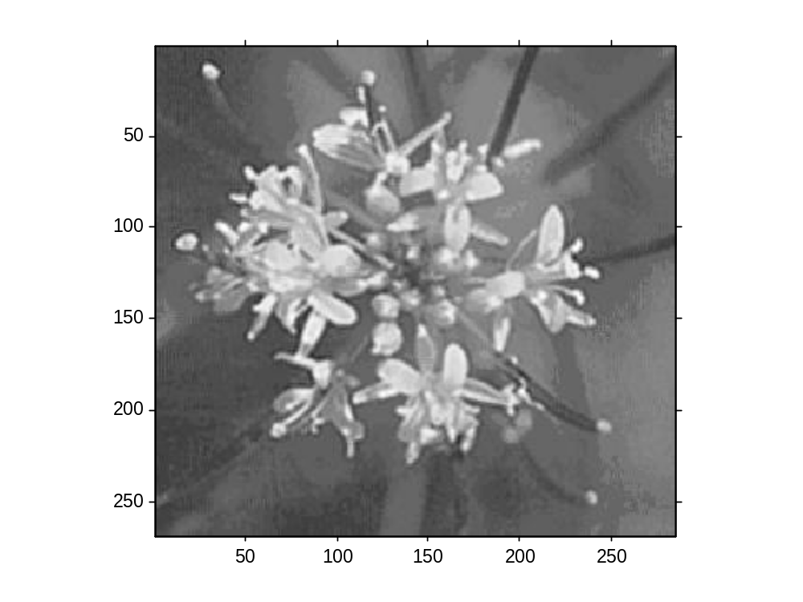

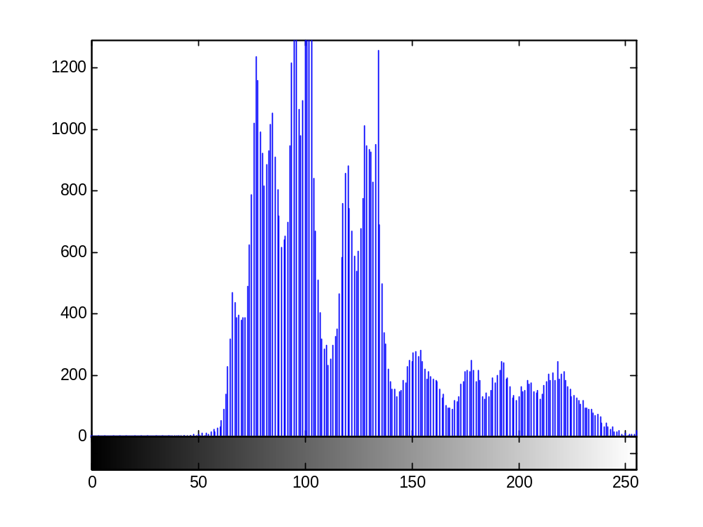

>> I = imread('C:\IMAGES\SWAN.PGM');
>> figure,imshow(I);
>> figure,imhist(I);

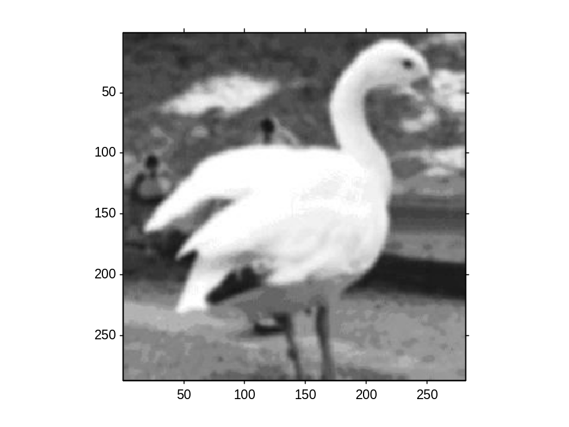

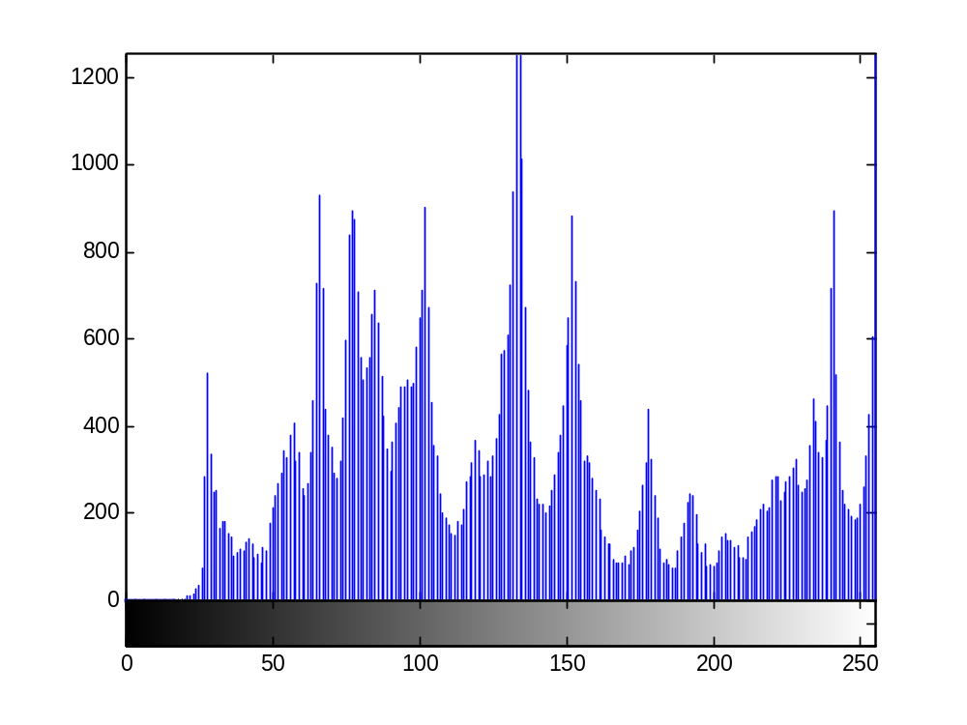

>> I = imread('C:\IMAGES\TOOLS.PGM');
>> figure,imshow(I);
>> figure,imhist(I);
